**SQL QUERIES**

**1. Count of transactions provided.**

**SQL Query:**

SELECT

COUNT(DISTINCT transaction_id) count_transactions

FROM

coffee_shop_sales;

**OUTPUT:**



**2. Store id and their corresponding locations.**

**SQL QUERY:**

SELECT

DISTINCT store_id, store_location

FROM

coffee_shop_sales;

**OUTPUT:**

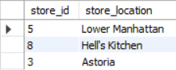

**3. Category of products available in each store.**

**SQL QUERY:**

SELECT

DISTINCT store_id, product_category

FROM

coffee_shop_sales

ORDER BY

store_id;

**OUTPUT:**

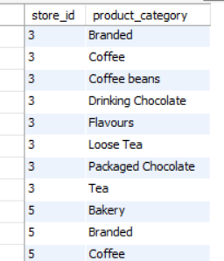

**4. Product category and their corresponding types.**

**SQL QUERY:**

SELECT

DISTINCT Product_category, product_type

FROM

coffee_shop_sales

ORDER BY

Product_category;

**OUTPUT:**

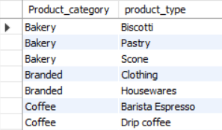

**5. count of product categroies and product type in each store.**

**SQL QUERY:**

SELECT

COUNT(DISTINCT Product_category) count_product_category,

COUNT(DISTINCT product_type) count_product_type

FROM

coffee_shop_sales;

**OUTPUT:**



**6. Identify the daily total revenue and number of transactions.**

**SQL QUERY:**

SELECT

transaction_date, COUNT(transaction_id) transactions,

SUM(transaction_qty*unit_price) daily_revenue

FROM

coffee_shop_sales

GROUP BY

transaction_date;

**OUTPUT:**

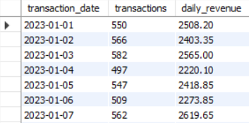

**7. Find the hour with the highest sales across all transactions.**

**SQL QUERY:**

SELECT

EXTRACT(HOUR FROM transaction_time) transaction_hour,

SUM(transaction_qty*unit_price) Hourly_revenue FROM coffee_shop_sales

GROUP BY

EXTRACT(HOUR FROM transaction_time)

ORDER BY

Hourly_revenue DESC;

**OUTPUT:**

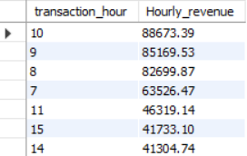

**8. List the top 5 best-selling products by revenue.**

**SQL QUERY:**

SELECT

product_id, product_type, SUM(transaction_qty*unit_price) total_revenue

FROM

coffee_shop_sales

GROUP BY

product_id, product_type

ORDER BY

total_revenue DESC

LIMIT 5;

**OUTPUT:**

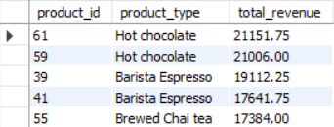

**9. List the top 5 best-selling products by quantity.**

**SQL QUERY:**

SELECT

product_id, product_type, SUM(transaction_qty) total_qty

FROM

coffee_shop_sales

GROUP BY

product_id, product_type

ORDER BY

total_qty DESC

LIMIT 5;

**OUTPUT:**

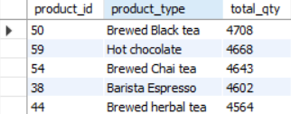

**10. Calculate the total revenue generated by each product category.**

**SQL QUERY:**

SELECT

product_category, SUM(transaction_qty*unit_price) total_revenue

FROM

coffee_shop_sales

GROUP BY

product_category

ORDER BY

total_revenue DESC;

**OUTPUT:**

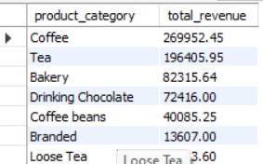

**11. Compare the total revenue and number of transactions for each store.**

**SQL QUERY:**

SELECT

store_id, SUM(transaction_qty*unit_price) total_revenue,

SUM(transaction_qty) total_qty

FROM

coffee_shop_sales

GROUP BY

store_id;

**OUTPUT:**

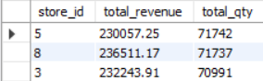

**12. Calculate total sales for each respective month.**

**SQL QUERY:**

SELECT

EXTRACT(MONTH FROM transaction_date) month_name,

SUM(transaction_qty*unit_price) total_sales

FROM

coffee_shop_sales

GROUP BY

EXTRACT(MONTH FROM transaction_date);

**OUTPUT:**

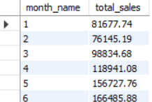

**13. Determine month-on-month decrease or increase in sales.**

**SQL QUERY:**

SELECT

MONTH(transaction_date) month_no, SUM(transaction_qty*unit_price)

total_sales, ROUND((SUM(transaction_qty*unit_price)-

LAG(SUM(transaction_qty*unit_price)) OVER(ORDER BY

MONTH(transaction_date) ASC))/LAG(SUM(transaction_qty*unit_price))

OVER(ORDER BY MONTH(transaction_date) ASC) * 100,2) MOM_Percentage

FROM

coffee_shop_sales

GROUP BY

MONTH(transaction_date);

**OUTPUT:**

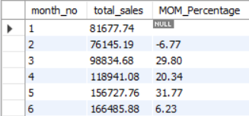

**14. Determine month on month decrease or increase in total quantity.**

**SQL QUERY:**

SELECT MONTH(transaction_date) month_no, SUM(transaction_qty) total_qty,

ROUND((SUM(transaction_qty)-LAG(SUM(transaction_qty)) OVER(ORDER BY

MONTH(transaction_date) ASC))/LAG(SUM(transaction_qty)) OVER(ORDER BY

MONTH(transaction_date) ASC) * 100,2) MOM_Percentage

FROM

coffee_shop_sales

GROUP BY

MONTH(transaction_date);

**OUTPUT:**

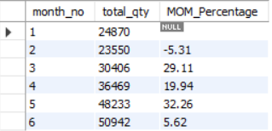

**15. Daily sales for a selected month.**

**SQL QUERY:**

SELECT

DAY(transaction_date) day_no, SUM(transaction_qty*unit_price) total_sales

FROM

coffee_shop_sales

WHERE

MONTH(transaction_date) =5

GROUP BY

DAY(transaction_date);

**OUTPUT:**

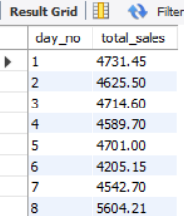

**16. Comparing daily sales with average sales. If greater than print "Above Average" less than "Below Average".**

**SQL QUERY:**

SELECT day_no,totalsales, avgsales,

CASE WHEN totalsales>avgsales THEN "Above Average"

WHEN totalsales<avgsales THEN "Below Average"

END sales_status

FROM

(SELECT DAY(transaction_date) day_no,SUM(transaction_qty*unit_price) totalsales, AVG(SUM(transaction_qty*unit_price)) OVER() avgsales

FROM

coffee_shop_sales

WHERE

MONTH(transaction_date) =5

GROUP BY

DAY(transaction_date)) sales_data;

**OUTPUT:**

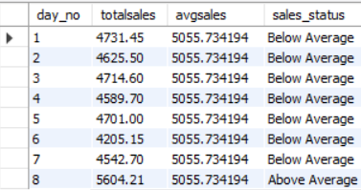

**17. Total sales on weekdays and weekends.**

**SQL QUERY:**

SELECT

CASE

WHEN DAYOFWEEK(transaction_date) IN (1,7) THEN "Weekend"

ELSE "Weekday"

END day_type

, SUM(transaction_qty*unit_price) sales

FROM

coffee_shop_sales

GROUP BY

day_type;

**OUTPUT:**

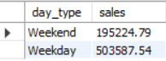

**18. Sales from each store location on a particular month.**

**SQL QUERY:**

SELECT

store_location, SUM(transaction_qty*unit_price) totalsales

FROM

coffee_shop_sales

WHERE

MONTH(transaction_date) =5

GROUP BY

store_location**;**

**OUTPUT:**

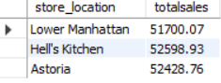

**19. To view sales in a week in a particular month.**

**SQL QUERY:**

SELECT

CASE

WHEN DAYOFWEEK(transaction_date) = 2 THEN 'Monday'

WHEN DAYOFWEEK(transaction_date) = 3 THEN 'Tuesday'

WHEN DAYOFWEEK(transaction_date) = 4 THEN 'Wednesday'

WHEN DAYOFWEEK(transaction_date) = 5 THEN 'Thursday'

WHEN DAYOFWEEK(transaction_date) = 6 THEN 'Friday'

WHEN DAYOFWEEK(transaction_date) = 7 THEN 'Saturday'

ELSE 'Sunday'

END AS Day_of_Week,

ROUND(SUM(unit_price * transaction_qty)) AS Total_Sales

FROM

coffee_shop_sales

WHERE

MONTH(transaction_date) = 5

GROUP BY

Day_of_Week;

**OUTPUT:**

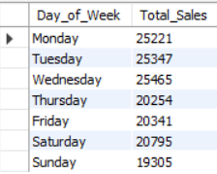

**20. calculates total sales by product and then selects only those products where sales exceed the average sales.**

**SQL QUERY:**

WITH Product_sales AS(

SELECT

product_id, product_type, SUM(unit_price * transaction_qty) AS Total_Sales

FROM

coffee_shop_sales

GROUP BY

product_id, product_type

)

SELECT

product_id, product_type, Total_Sales

FROM

Product_sales

WHERE

Total_Sales>(SELECT AVG(Total_Sales) AS Avg_Sales FROM Product_sales);

**OUTPUT:**

